H.T No
Regulations:
A15

Sreenidhi Institute of Science and Technology
(An Autonomous Institution)
Code No: 5A242 Date: 03-Nov-2021 (AN)

B.Tech I-Year II- Semester External Examination, Oct/Nov - 2021 (Supplementary)
NETWORK ANALYSIS (ECE and ECM)

Time: 3 Hours Max.Marks:75

Note: a) No additional answer sheets will be provided.
b) All sub-parts of a question must be answered at one place only, otherwise it will not be valued.
c) Missing data can be assumed suitably.

ANSWER ANY 5 OUT OF 8 QUESTIONS. EACH QUESTION CARRIES 15 MARKS.

Bloom's Cognitive Levels of Learning (BCLL)

Remember | L1 | Apply | L3 | Evaluate | L5
Understand | L2 | Analyze | L4 | Create | L6

 |  |  | BCLL | CO(s) | Marks
1. | a) | When a dc voltage is applied to a capacitor, the voltage across its terminals is found to buildup in accordance with Vc= 50(1-e^{-100t}). After a lapse of 0.01s, the current flow is equal to 2mA.  i) Find the value of capacitance in micro farads.  ii) How much energy is stored in the electric field at this time? | L5 | CO1 | [8M]
 | b) | Solve the equations for Mesh current for the network given below.  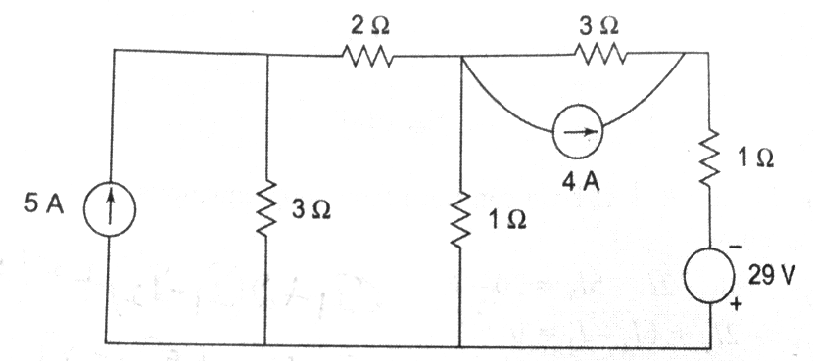 | L5 | CO1 | [7M]
2. | a) | What is duality and dual network? Illustrate the procedure for drawing the dual of a given network. | L2 | CO2 | [8M]
 | b) | Find the cut-set matrix of the network shown in figure and obtain the relationship between the branch currents.  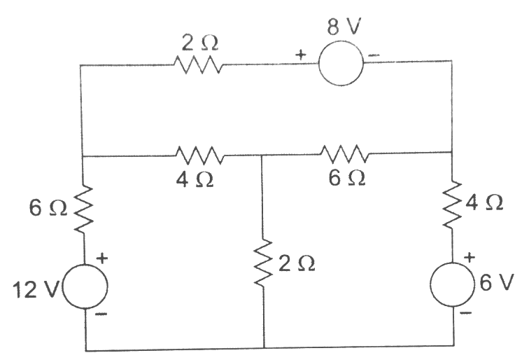 | L5 | CO2 | [7M]
3. | a) | For the circuit shown in figure, determine the power output of the source and the power in each resistor of the circuit.  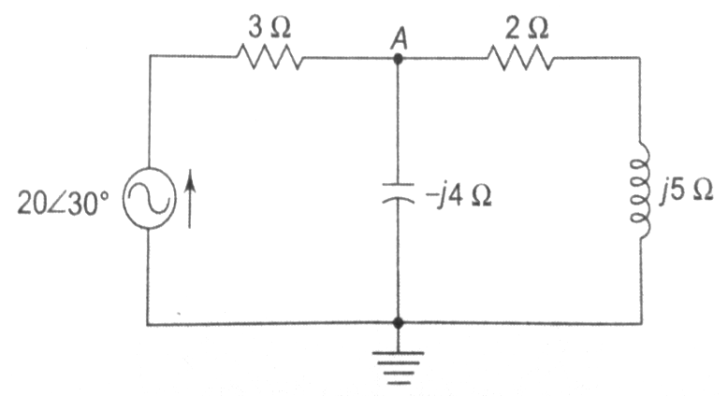 | L5 | CO3 | [8M]
 | b) | A series RLC circuit with Q=250 is resonant at 1.5MHz. Find the frequencies at half power points and also bandwidth. | L4 | CO3 | [7M]
4. | a) | Verify reciprocity theorem for the given network.  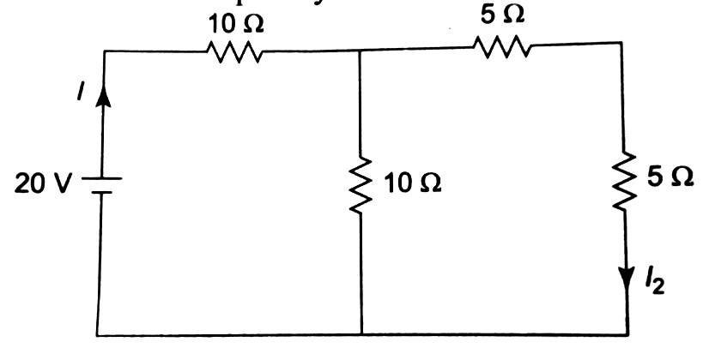 | L3 | CO4 | [8M]
 | b) | Apply superposition theorem and find V_{AB}.  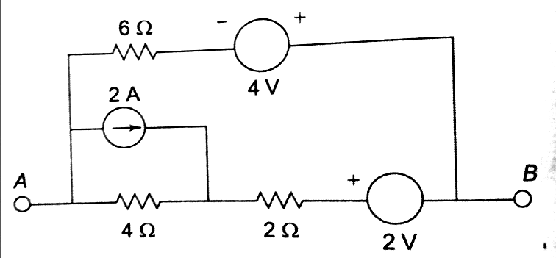 | L3 | CO4 | [7M]
5. | a) | Explain the interrelationships between Z-parameters and ABCD parameters for a two-port network. | L2 | CO5 | [8M]
 | b) | Discuss the different types of filters. | L3 | CO5 | [7M]
6. | a) | Illustrate the DC response of a RLC series circuit with a neat sketch. | L4 | CO6 | [8M]
 | b) | Find the laplace transform of the function f(t) = 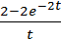 | L5 | CO6 | [7M]
7. | a) | Calculate the voltage V for the circuit shown below which makes the current in 10Ω resistor zero by using nodal analysis.  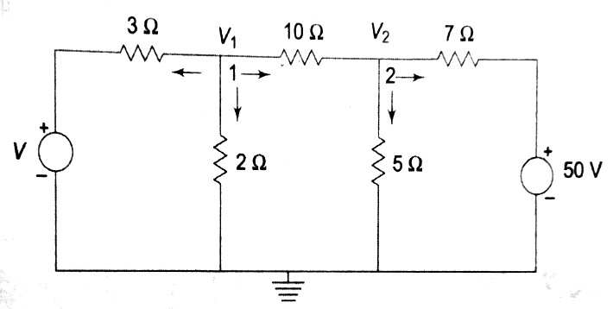 | L5 | CO1 | [5M]
 | b) | Draw the oriented network graph form the incidence matrix given below. | L3 | CO2 | [5M]
  Nodes | Branches
  Nodes | 1 | 2 | 3 | 4 | 5 | 6
  A | -1 | 0 | 0 | 1 | -1 | 0
  B | 1 | -1 | 0 | 0 | 0 | -1
  C | 0 | 1 | -1 | 0 | 1 | 0
  D | 0 | 0 | 1 | -1 | 0 | 1
 | c) | Derive the equation for equivalent inductance when two inductors are coupled in series opposing and mutual inductance exists between them. | L3 | CO3 | [5M]
8. | a) | Verify Tellegen’s theorem for the network shown in figure  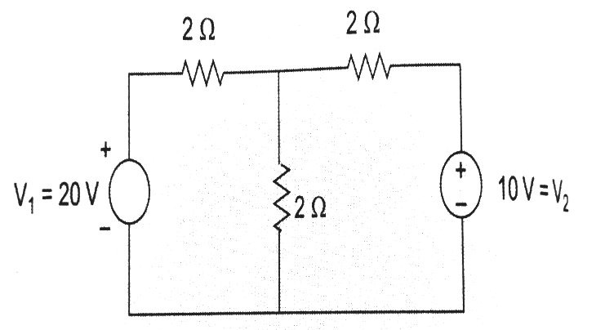 | L3 | CO4 | [5M]
 | b) | Find the h parameters for the network shown below.  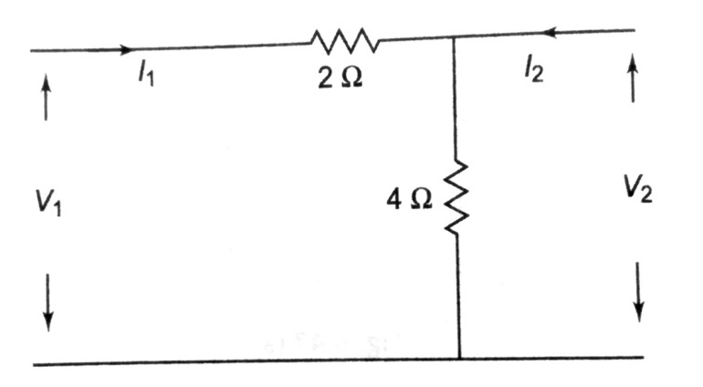 | L5 | CO5 | [5M]
 | c) | A series RC circuit consists of resistor of 10Ω and capacitor of 0.1F as shown in figure. A constant voltage of 20V is applied to the circuit at t=0. Obtain the current equation.  Determine the voltage across resistor and the capacitor.  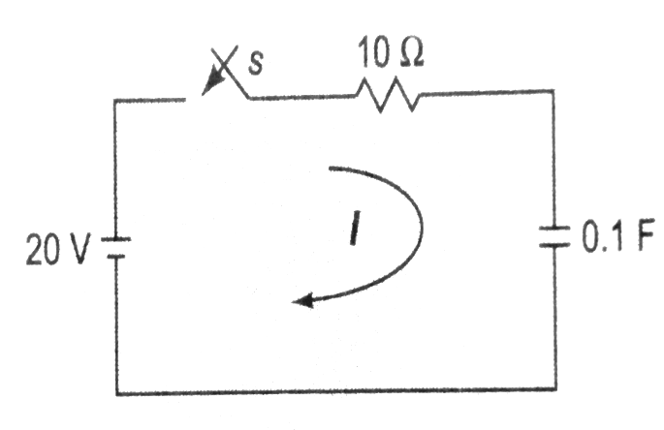 | L5 | CO6 | [5M]

-- 00 -- 00 –

